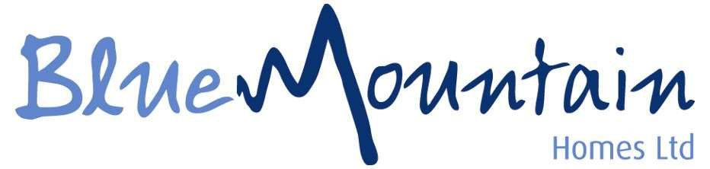

Equipping and empowering each young person to fulfil their potential and find their positive pathway in a safe environment.
We are committed to providing individualised care, education, and opportunity.

Job Description
Deputy Manager


Job Title: Deputy Manager
Responsible to: Manager of the Home

Job Purpose
To be a part of a team offering a comprehensive residential service to children and young people, the aim being to ensure the physical, social and emotional care, and development of the young residents and the establishment.
You will be caring for young people with Emotional Behaviour Difficulties and Learning Disabilities.
We use a child centred approach in which the child’s wishes and views are listened to and acted on. You would be an inspirational member of your team and ensure outstanding care is always provided for our young people.

Main Duties & Responsibilities

- Assist the management of the home in developing the skills and potential of residential support workers.

- Take responsibility for the effective and efficient running of shifts.

- Work within, and ensure effective delivery of the policies and procedures in the home, and the company.

- Monitor and maintain administrative requirements, ensuring that the outcome meets the standards set out in children’s legislation, and the homes working practices.

- Ensure ongoing assessment of children and young people’s needs in day to day practice.

- Oversee, supervise and develop the skills of staff in their daily working practice.

- Promote and actively encourage the delivery of a safe, structured and nurturing environment.

- Work as part of a multi disciplinary team both within the home and with external agencies.

- Relate to and engage young people who display challenging behaviour.

- At all times ensure the health, safety and wellbeing of the children and young people.

- Ensure staff are aware of and deliver the support required to ensure the life chance opportunities of children and young people are met in relation to their social, educational, leisure, emotional, physical and cultural needs.

- Ensure the delivery of all key worker areas and responsibilities.

- Ensure a variety of intervention strategies are utilised in relation to behaviour management.

- Where required Deputise in the absence of the Manager of the home.

- Where required attend reviews and or meetings.

- Ensure an open culture is created so that children and young people feel they can complain and that they are listened to.

- Ensure that all administrative requirements of the home are maintained in such a way that they are compliant with good childcare practices, homes procedures, company policies and children’s regulations.

- At all times promote and ensure anti discriminatory practice.

- Oversee, write and edit all reports when submitted for meeting and reviews.

- Undertake all relevant training as and when required. You must co-operate with the Company in complying with the Health and Safety requirements and are therefore expected to follow Company policies, to acquaint yourself with the Fire, Health and Safety Procedures at your place of work and report any unsafe practices and conditions.

The post holder may be reasonably expected to undertake other duties commensurate with the level of responsibility that may be allocated from time to time. It is the responsibility of the post holder to comply with Health and Safety and Equal Opportunities requirements at all times.


Additional Information

Our normal shift patterns are on a rolling rota basis and our shift working hours are: 07.30am-23.00pm per shift, which means days of working can vary from week to week.
Sleep in shifts are required, the amount depends on the routine of the home.
The successful candidate must have experience working in a Children's Home and will already have achieved the Level 3 Diploma in Children's Residential Care/Level 4 Children, Young People and Families Practitioner.

All applicants must have a valid manual UK/EU Driving Licence.

We operate using Safer Recruitment at all times so any offer of employment would be dependent on the necessary checks and enhanced DBS.

Schedule  Shift work 7.30am – 11pm  Shift Patterns – Dependent on home  Two days on 4 days off rolling rota  Sleep ins required | Salary  Up to £40,496 depending on experience, qualifications and sleeps per annum.  £60 per sleep | Job Types  Full Time

Staff Benefits

- Company pension 3% Employer Pension Contribution
- 224 hours Annual Leave
- Bank Holiday at Double Pay
- Competitive salary with incentivised overtime at plus £3.50 p/hour
- Free DBS Check
- Referral programme up to £500
- Store discount
- Employee Wellbeing service
- Career Progression for all Roles
- Therapeutic training for all staff
- Quarterly Recognition Awards
- Food Available on Shift

General Statement

The above duties and responsibilities do not include or define all tasks that may be required by the postholder. The duties and responsibilities may vary without changing the general character of the duties or the level of responsibility entailed.

Equal Opportunities
Blue Mountain Homes supports Equal Opportunities in Employment and opposes all forms of unlawful discrimination on grounds such as colour, race, nationality, ethnic or national origin, sex, marital status, disability, sexual orientation, religion or belief and age. You are expected to comply at all times to the Companies EO Policy and Guide to Equality document.

The above job description forms part of your Main Terms and Conditions of Employment. The Company reserves the right to vary duties and responsibilities at anytime.

Signed……………………………………………………………… Date………………………………………

