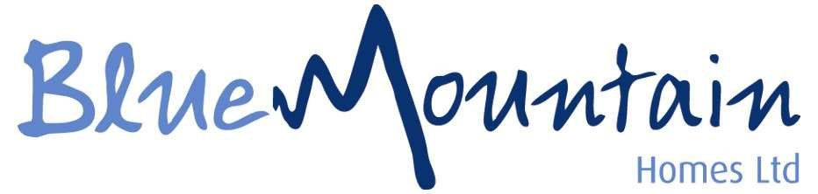

Equipping and empowering each young person to fulfil their potential and find their positive pathway in a safe environment.
We are committed to providing individualised care, education, and opportunity.

Job Description

Waking Night Childrens Residential Care Worker

Job Title: Waking Night Childrens Residential Care Worker
Responsible to: Manager of the Home

Job Purpose
To be a part of a team offering a comprehensive residential service to children and young people, the aim being to ensure the physical, social and emotional care, and development of the young residents and the establishment.
You will be caring for young people with Emotional Behaviour Difficulties and Learning Disabilities.
We use a child centred approach in which the child’s wishes and views are listened to and acted on. You would be an inspirational member of your team and ensure outstanding care is always provided for our young people.

Main Duties & Responsibilities
- To carry out duties in line with Blue Mountain homes policies and procedures.

- To ensure the safety and wellbeing of the children and young people through the night time period.

- To be fully aware of safeguarding and child protection issues.

- To fully understand the reporting process of child protection within the home.

- To understand the principals of safeguarding ones self.

- To have a full understanding of the emergency on call procedures of the home.

- To promote structure, boundaries and domestic routines within the home.

- Working in line with young peoples care and placement plans.

- To work in accordance with the National Minimum Care Standards for Children’s homes and co-operate with any inspection process.

- Provide a positive role model for the young people, presenting yourself in a highly professional manner.

- Work in partnership with other agencies to the benefit of the young people.

- To ensure that the building is secured throughout the night time hours.

- Undertake relevant training programmes as required by the National Minimum Care Standards.

- Complete and maintain administrative records as required by the home.

- Provide and participate in leisure activities in line with the care and placement plans of the young people were required.

- Develop and maintain professional working relationships with colleagues, children and families

- Attend and participate in supervision and staff meetings as required in the National Minimum Care Standards.

- To work as part of a team with colleagues and other professional to meet the social, emotional, educational, health and mental health needs of young people.

- Awareness and responsibility for the health and safety of the home, children, young people, colleagues and yourself.

- You must co-operate with the Company in complying with the Health and Safety requirements and are therefore expected to follow Company policies, to acquaint yourself with the Fire, Health and Safety Procedures at your place of work and report any unsafe practices and conditions.

The post holder may be reasonably expected to undertake other duties commensurate with the level of responsibility that may be allocated from time to time. It is the responsibility of the post holder to comply with Health and Safety and Equal Opportunities requirements at all times.

Person Specification

Skills & Abilities

Essential

- Ability to develop rapport and communicate with young people
- Ability to engage with young people and respond appropriately to challenging attitudes and behaviour
- Writing and Recording Skills
- Able to work well with a team
- Skills in leisure activities relevant to young people
- Ability to work under pressure
- Honesty and Integrity

Desirable
- Practical household skills such as cooking, minor repairs
- Computer Skills

Knowledge

Essential

- Appreciation of the needs of young people
- An understanding of the primary needs of young people

Desirable

- An understanding of the relevant legislation, e.g. Children Act
- NVQ level 3-HSC3 CYP or equivalent level.
- Knowledge of the needs of people with the relevant client group
- Knowledge of Child Protection Procedures

Experience

Desirable

- Experience of working with children or young people in need
- Working in a residential setting
- Group Work

Other

Essential

- Ability to work flexibly according to the needs of the service
- Personal commitment to own learning and acquisition of professional skills and qualifications
- Ability to benefit from supervisory and monitoring relationships
- Ability and commitment to work in culturally diverse environment
- Personal commitment to anti-oppressive care practices

Desirable

- Ability to travel as required on activities or to other BMH homes
- Clean driving licence



Additional Information

Our normal shift patterns are on a rolling rota basis, our shift working hours are:
22.00pm-08.00am shift patterns will mean days of working can vary from week to week.

All applicants must have a valid manual UK/EU Driving Licence.

We operate using Safer Recruitment at all times so any offer of employment would be dependent on the necessary checks and enhanced DBS.

Schedule  Shift pattern 10pm – 8am | Salary  £28,392 to £29,120 per annum depending on experience and qualifications | Job Types  Full Time

Staff Benefits

- Company pension 3% Employer Pension Contribution
- 224 hours Annual Leave
- Bank Holiday at Double Pay
- Funded Level 4 Apprenticeship
- Competitive salary with incentivised overtime at plus £3.50 p/hour
- Free DBS Check
- Referral programme up to £500
- Store discount
- Employee Wellbeing service
- Career Progression for all Roles
- Therapeutic training for all staff
- Quarterly Recognition Awards
- Food Available on Shift

General Statement

The above duties and responsibilities do not include or define all tasks that may be required by the postholder. The duties and responsibilities may vary without changing the general character of the duties or the level of responsibility entailed.

Equal Opportunities
Blue Mountain Homes supports Equal Opportunities in Employment and opposes all forms of unlawful discrimination on grounds such as colour, race, nationality, ethnic or national origin, sex, marital status, disability, sexual orientation, religion or belief and age. You are expected to comply at all times to the Companies EO Policy and Guide to Equality document.

The above job description forms part of your Main Terms and Conditions of Employment. The Company reserves the right to vary duties and responsibilities at anytime.

Signed……………………………………………………………… Date………………………………………

